**Test case summary:**

Check updates in customer’s shopping cart (Change Quantity, Delete, Keep for later, Enter promo code, Proceed to checkout)

Data to reproduce:

**Preconditions:**

There are 3 items in the cart. Search for ‘milk’ under the search bar in the landing page. A list of items with the keyword ‘milk’ will be populated. Add in 3 items, ‘Farm Fresh Chocolate Milk, ‘Meiji  
Deluxe Fresh Milk’ and ‘UFC Velvet Almond Milk – Original’. Each of the 3 products has 1 quantity each.

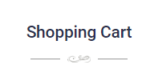

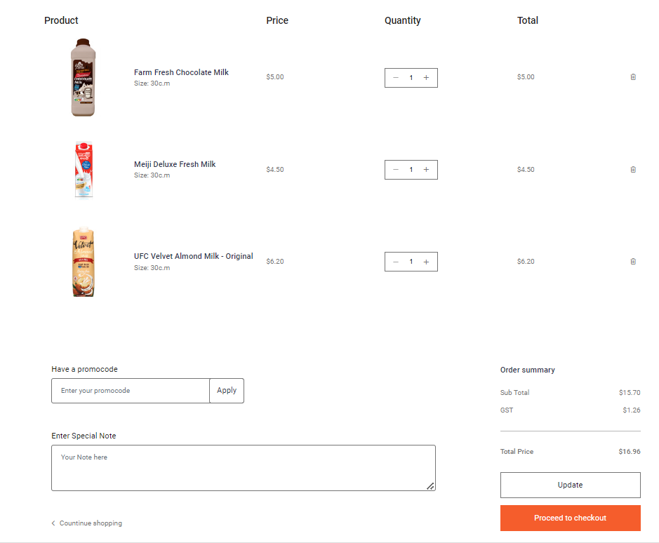

| **Test Case No** | **Test scenario** | **Expected Result** |
| --- | --- | --- |
| 1 | Click on the ‘bin’ icon on the extreme right side of ‘Farm Fresh Chocolate Milk’ product. | The ‘Farm Fresh Chocolate Milk’ product is deleted from the list. The ‘product removed’ message is displayed. |
| 2 | Click the ‘Update’ Icon. | New data is set. The Sub total displayed is $24.80, GST is $1.98 and the total price is $26.78. |
| 3 | Change the quantity of the other 2 products by clicking on “+’ or ‘- ‘ icon. | New data is set. The total of each of the other 2 products is updated accordingly. If ‘Meiji Deluxe Fresh Milk’ quantity is set to 2 and ‘UFC Velvet Almond Milk – Original’ quantity is set to 3, the prices of them are $9.00 and $18.60 respectively. |
| 4 | Click on the ‘Keep for later” button on any of the product. | The message ‘Item sent to favorites’ is displayed. The Item is removed from the shopping cart and is moved to the favorites page. New price subtotal is displayed on the cart page. |
| 5 | Enter any invalid promocode and click on apply | The error message “Invalid promocode’ has appeared. The subtotal has not been changed. It is still possible to checkout. |
| 6 | Enter a valid promocode and click on apply. | The message ‘promocode applied successfully’ is displayed. New data is set and there is a new line ‘Discount applied’ with (-value) under subtotal. The new subtotal is added to the (-value). |
| 7 | Enter a message under the ‘Enter Special note’ and click update button above the checkout button. | The message ‘special note saved successfully’ is displayed. The message will appear on the checkout page in the confirmation order. |
| 7 | Click the ‘Proceed to checkout’ button | The user is directed to the checkout page where he enters his delivery information, payment and shipping method to checkout as a guest. |

**Test data:**

Prepare a set of products

|  |  |  |  |  |
| --- | --- | --- | --- | --- |
| Product name | Quantity | Price | Valid Promocode | Invalid Promocode |
| Farm Fresh Chocolate Milk | 1 | $5 | GROCERY5  NEWDAY5  MILK5 | TEST1  TEST2  TEST3 |
| Meiji Deluxe Fresh Milk | 1 | $4.50 |
| UFC Velvet Almond Milk – Original | 1 | $6.20 |